Employee Management System with Spring Security

1. Let’s take a glance at the Project Structure

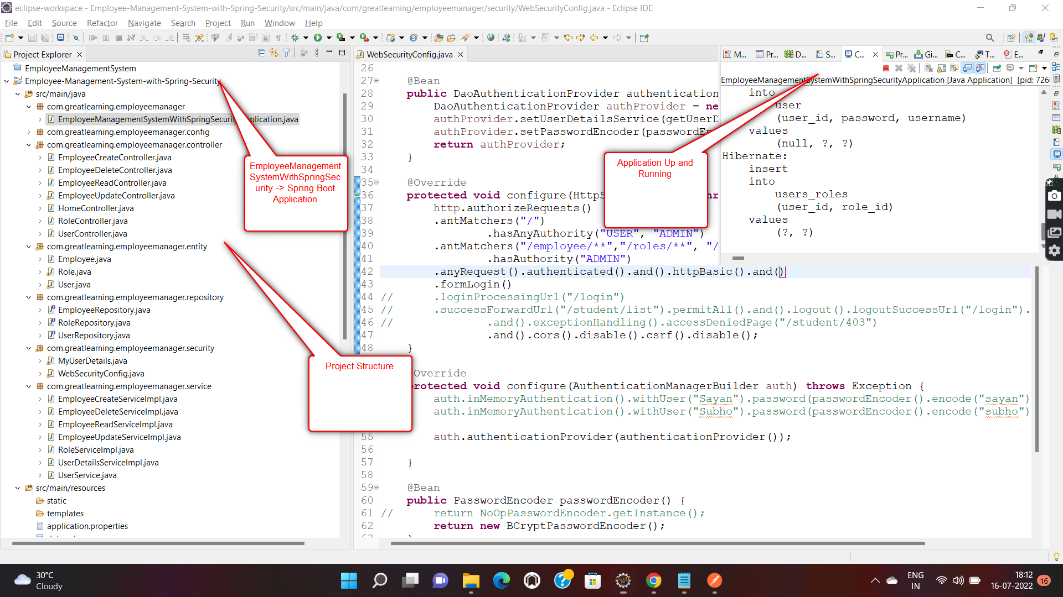

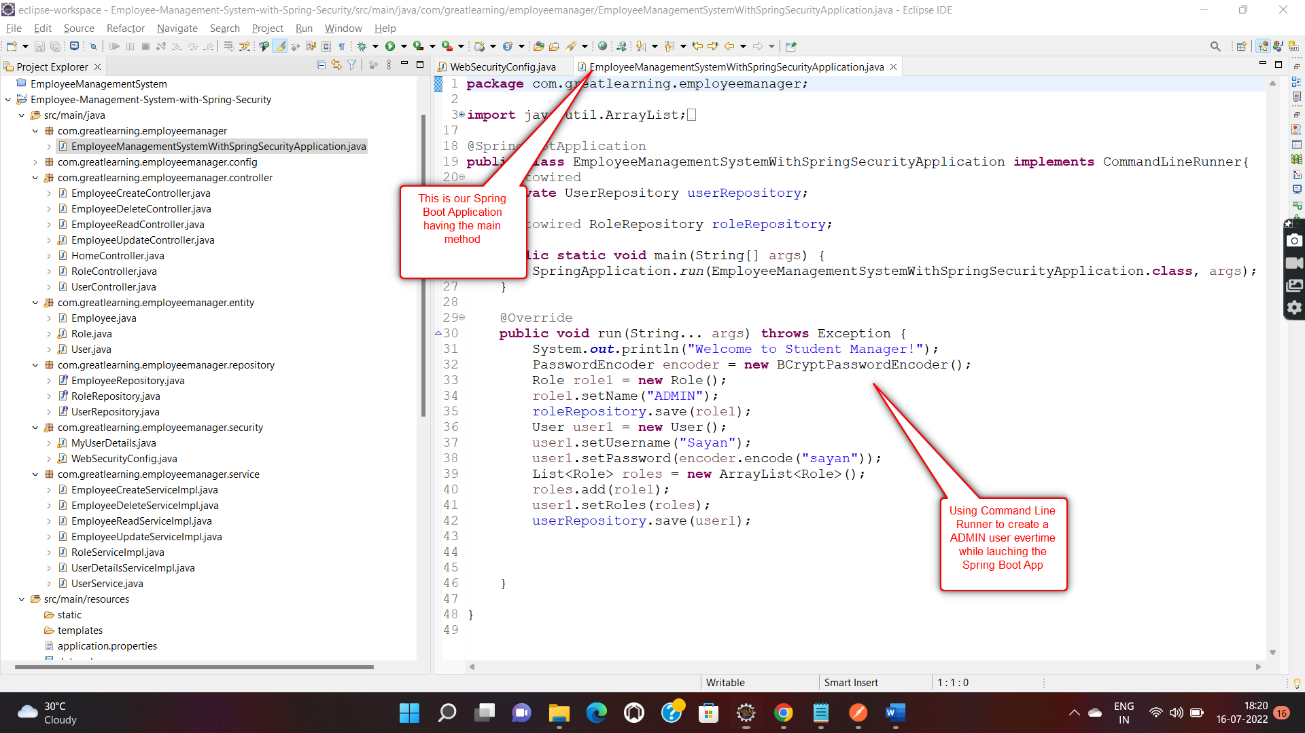

1. We are using h2 Database for storing our Entitity, i.e Employees and Users and Roles. Initially we are creating a default **ADMIN** user everytime while launching our Spring Boot Application.

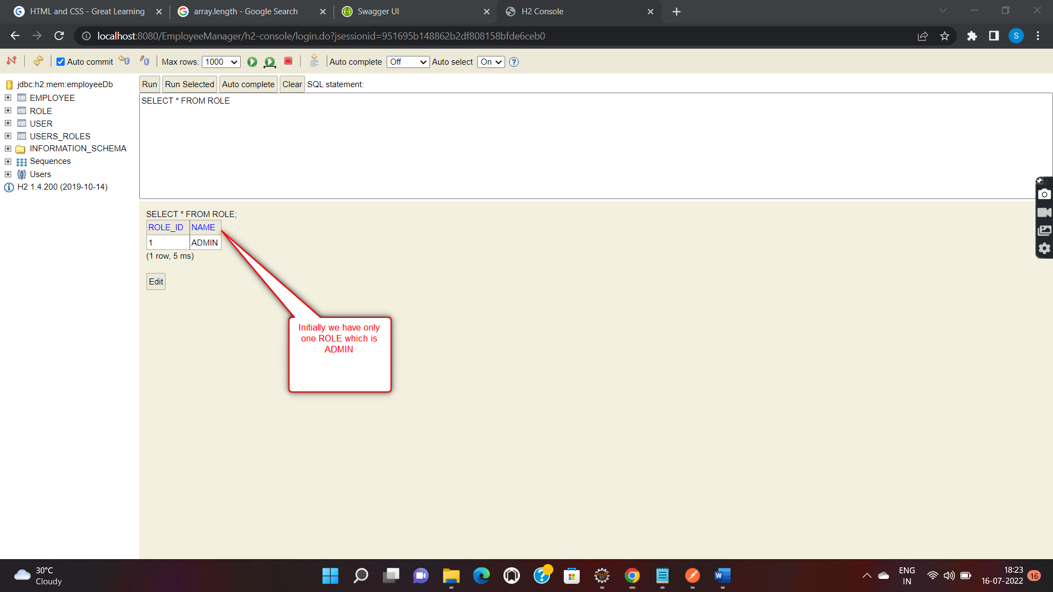

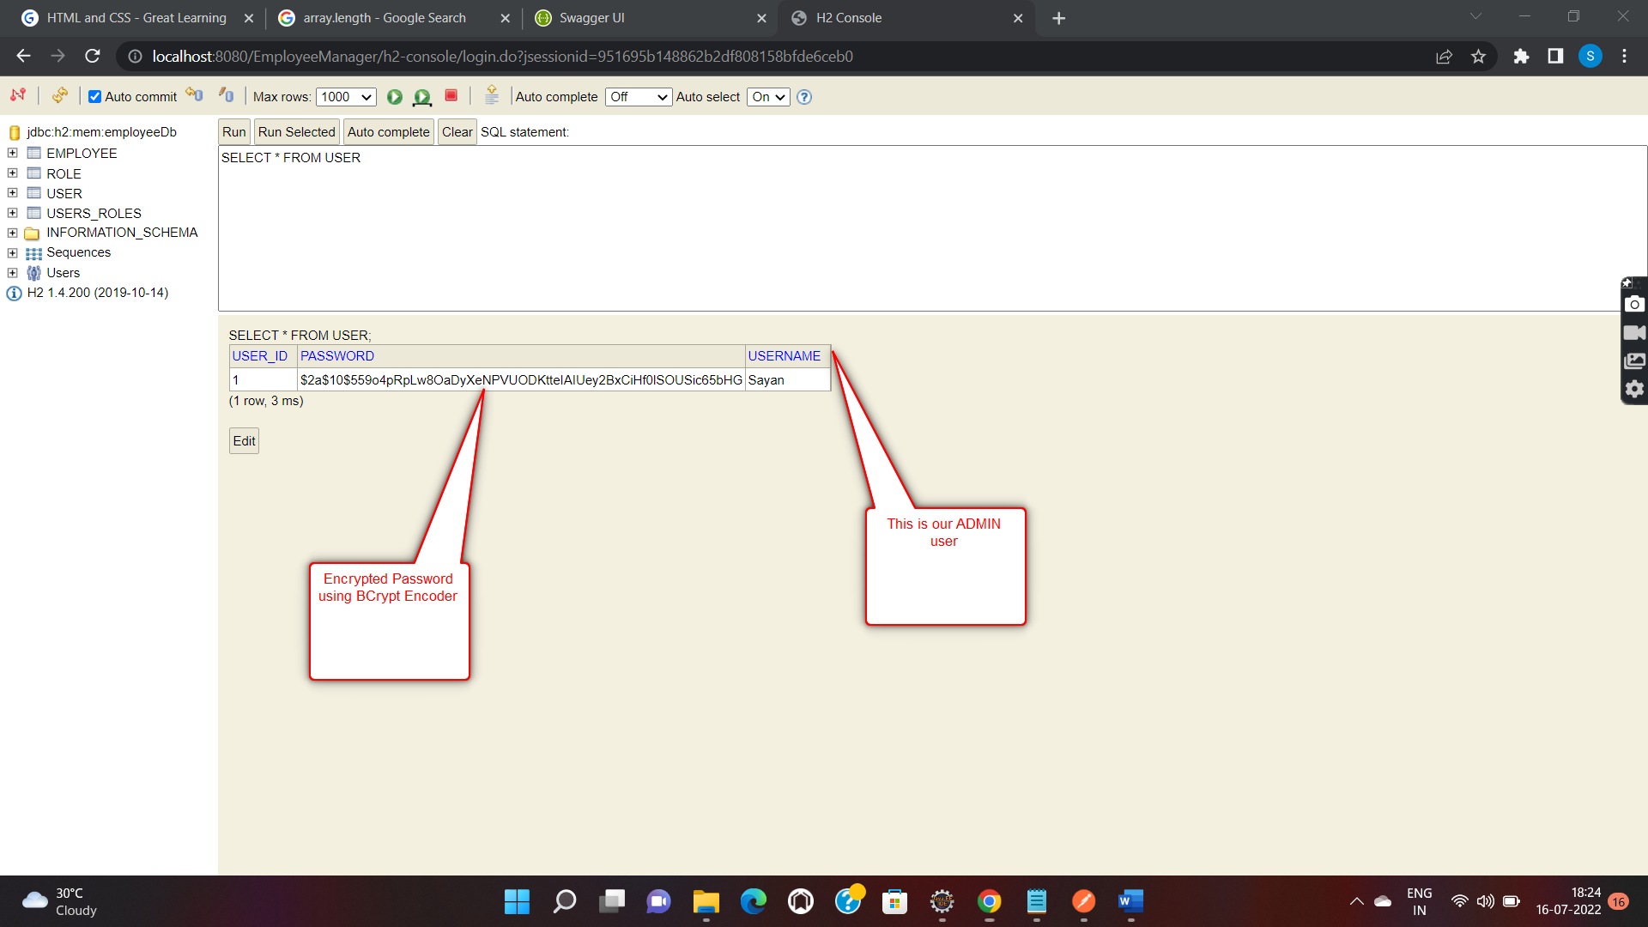

3)Let’s begin by going into our Postman and create a role for **USER.** Following which, we will create a new user and assign the **USER** role to it.

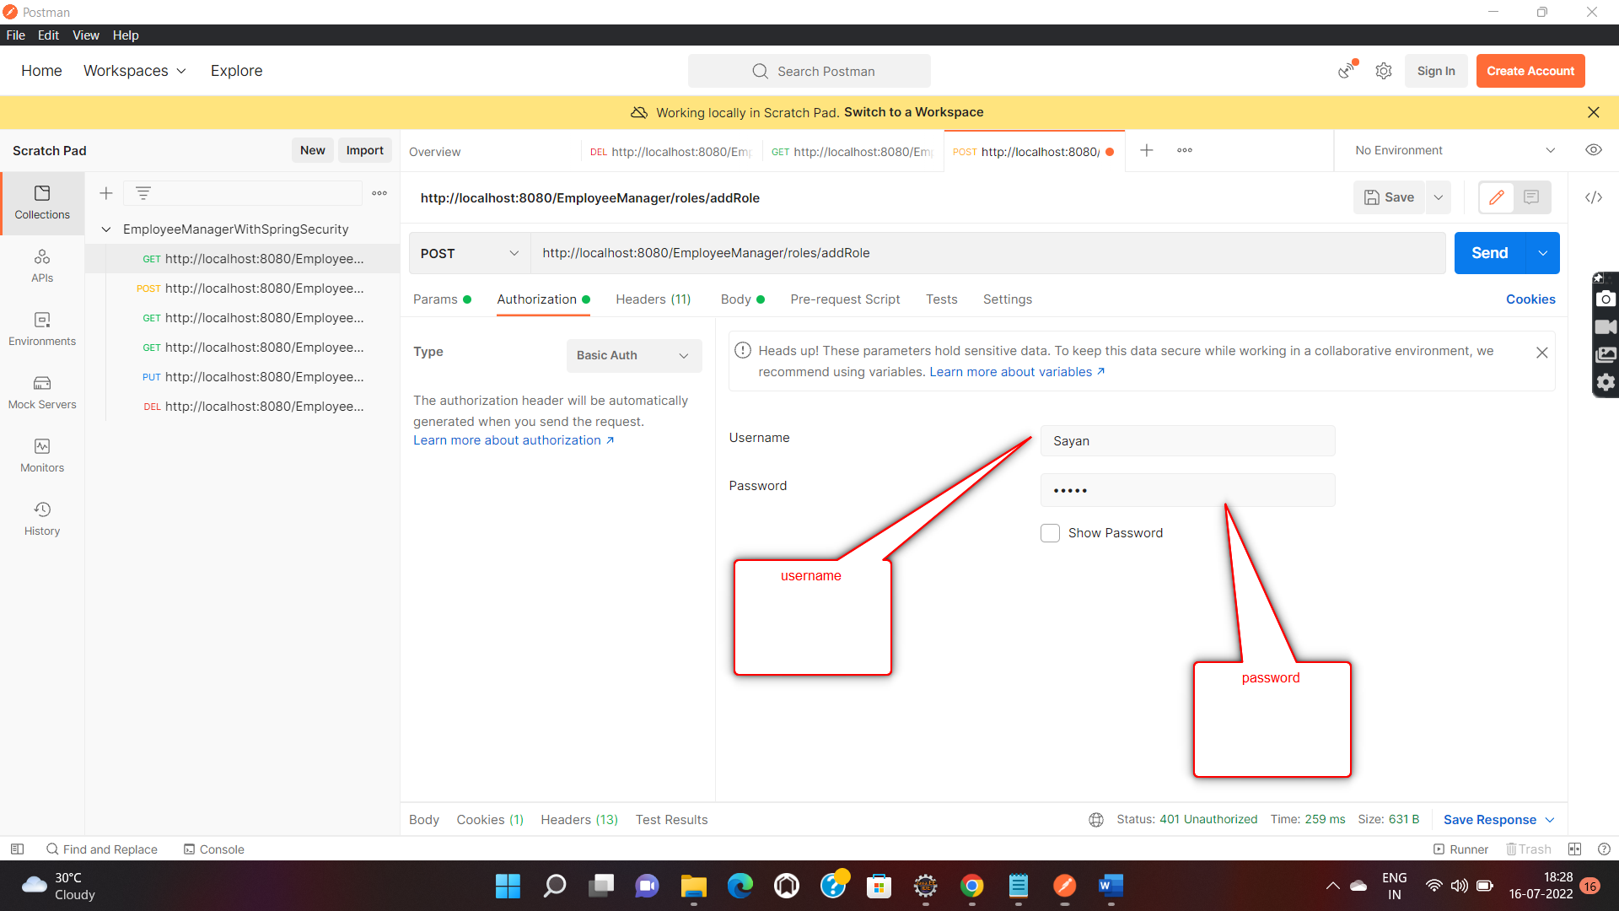

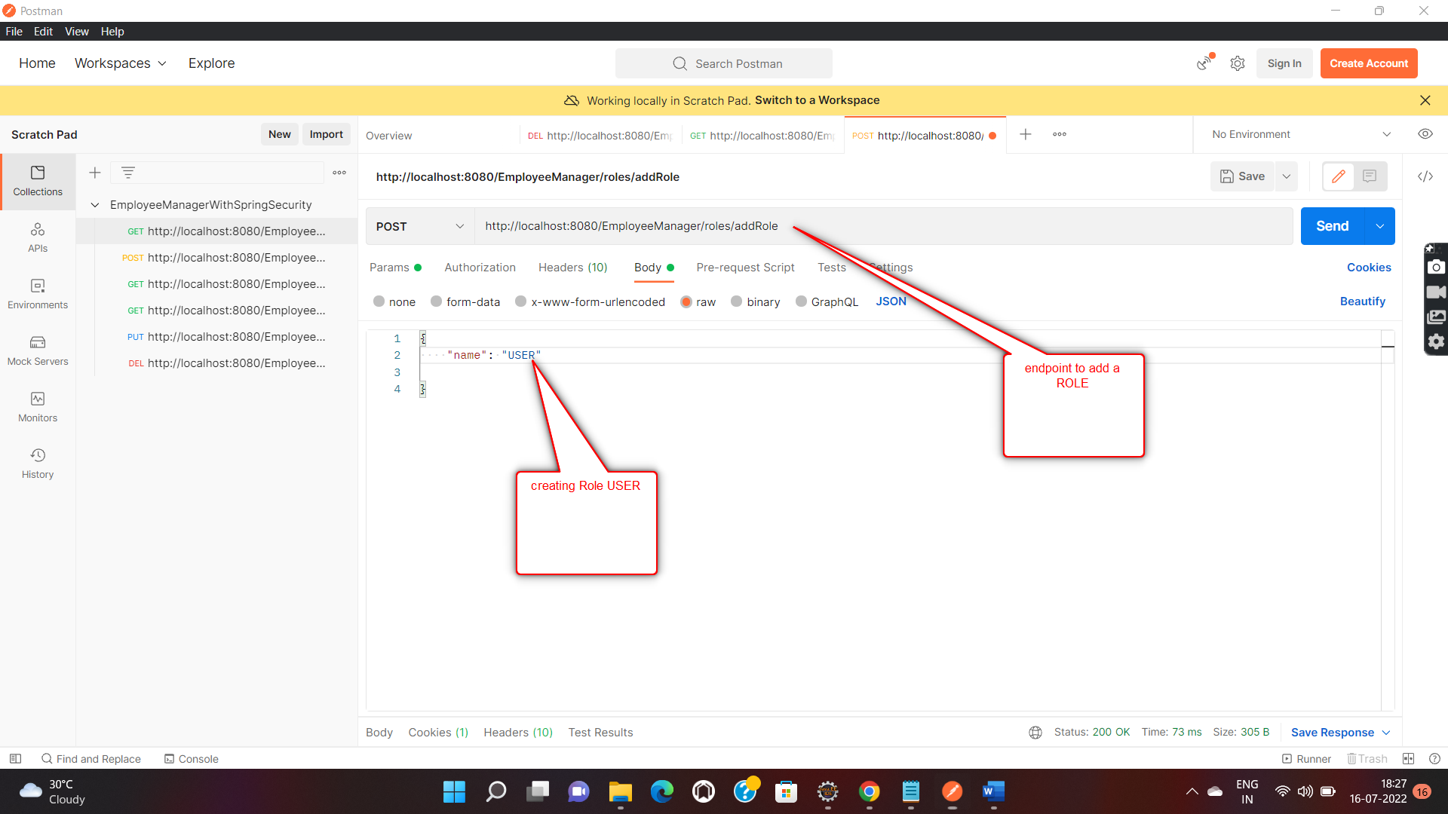

Response :

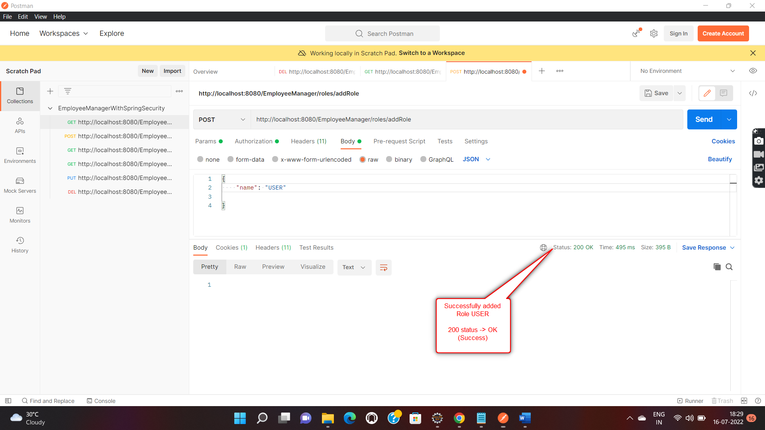

Let’s take a look at the h2 DB :

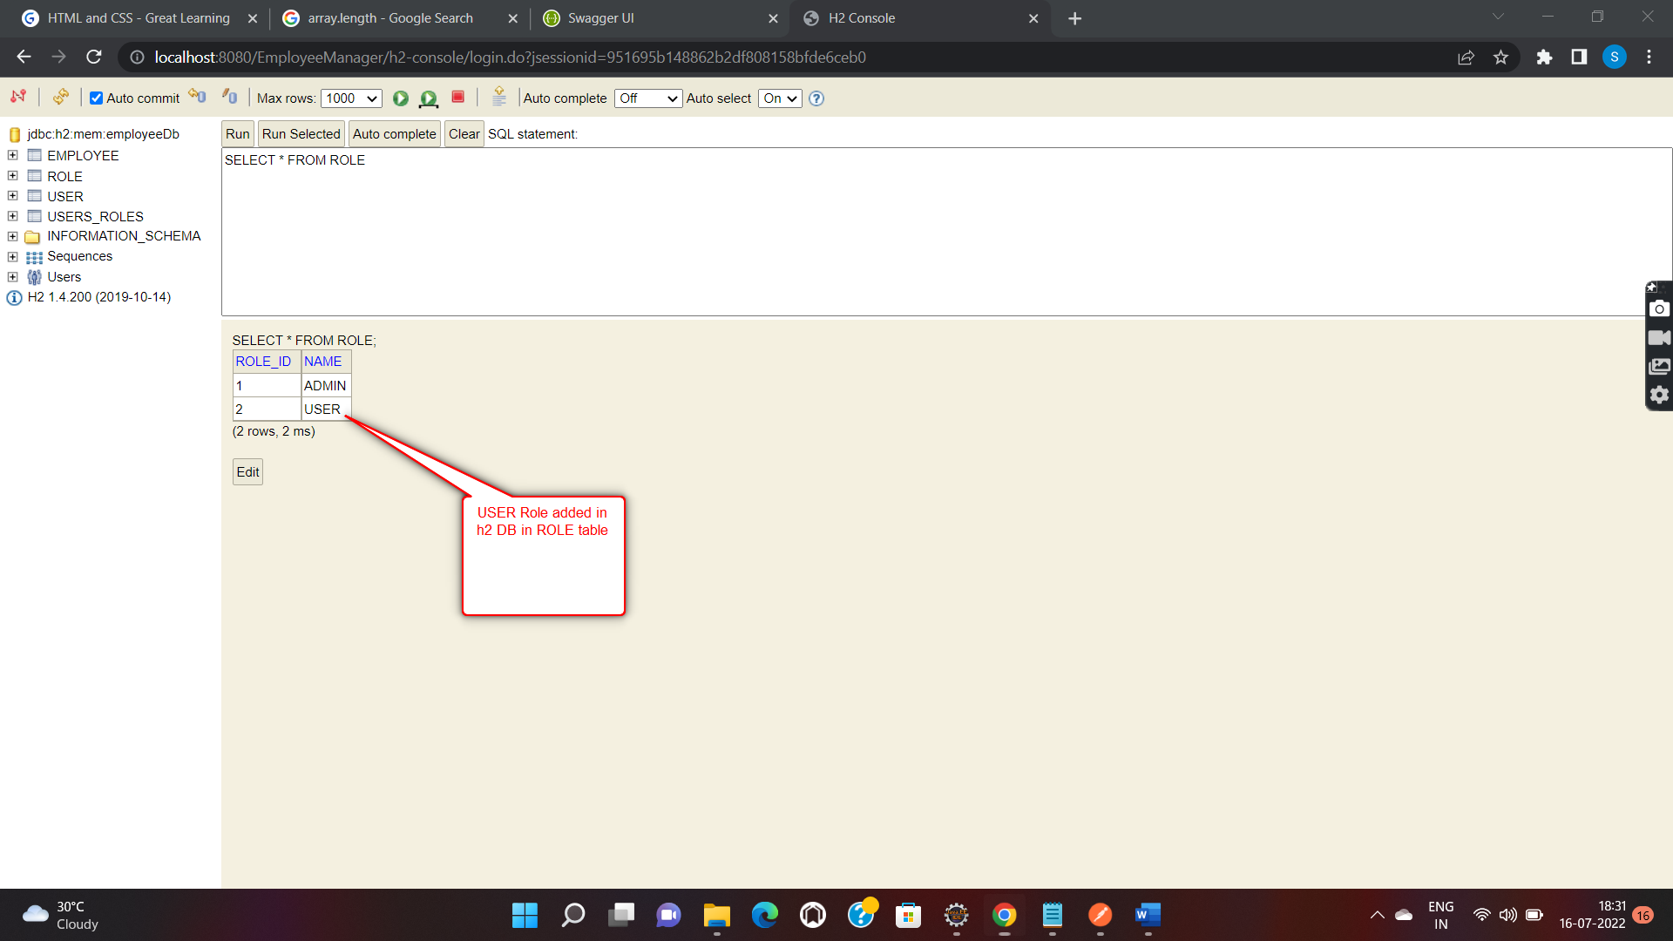

1. Now let’s create a new User and assign **USER** role to them. Note user, with **USER** role is not authorized to perform any sort of operations on our Entities.

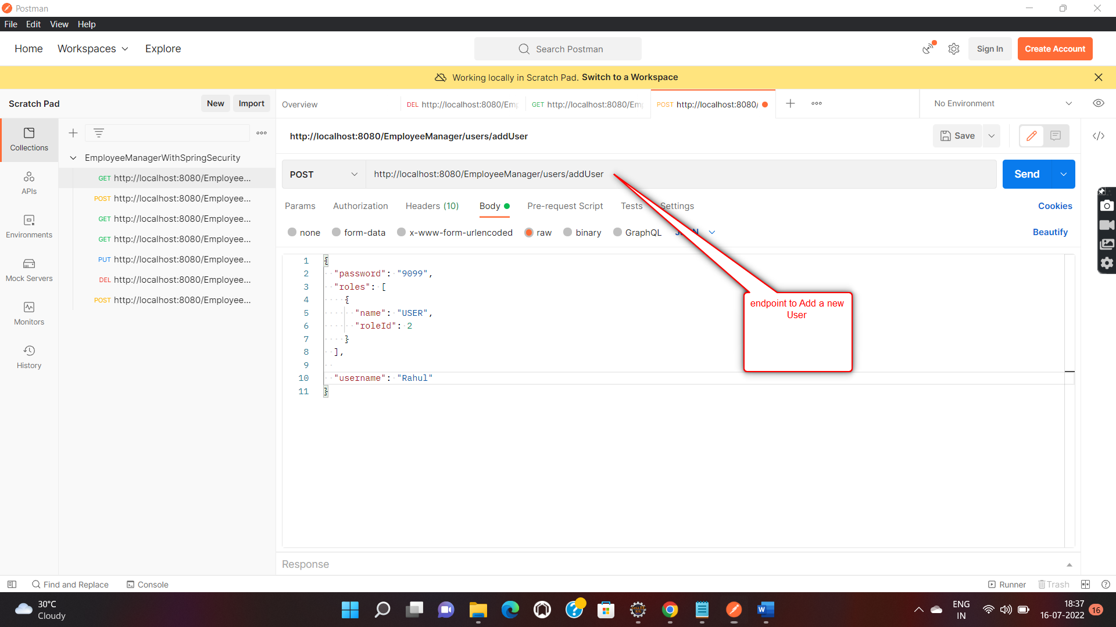

Response :

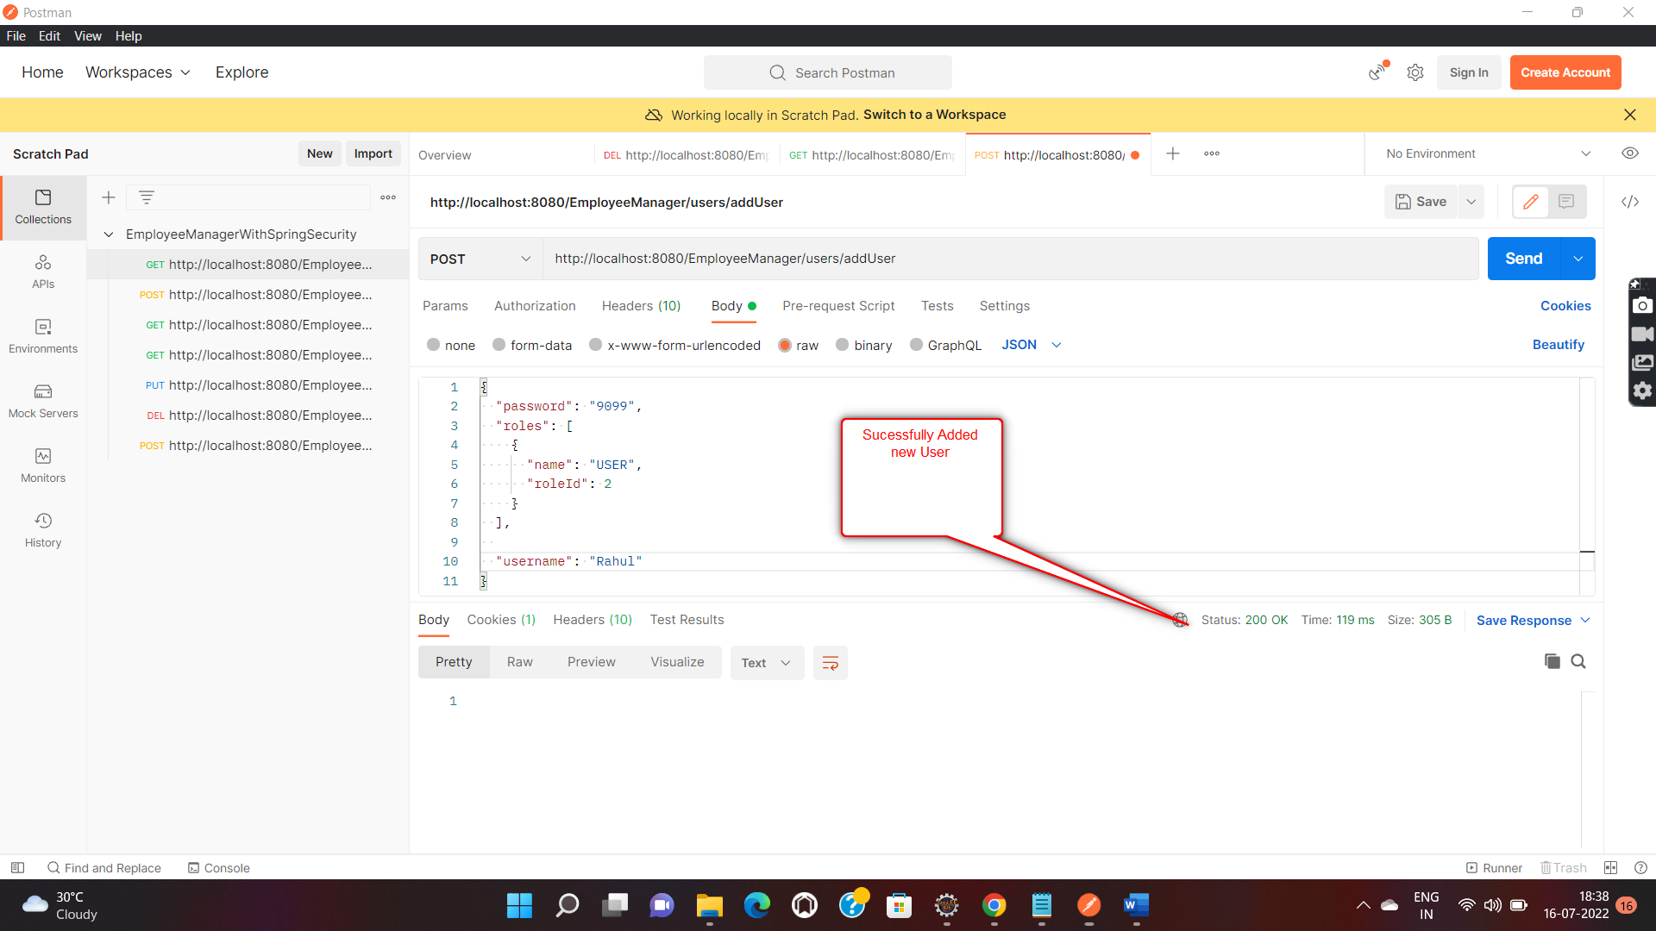

Let’s verify if user got added in h2 DB as well!

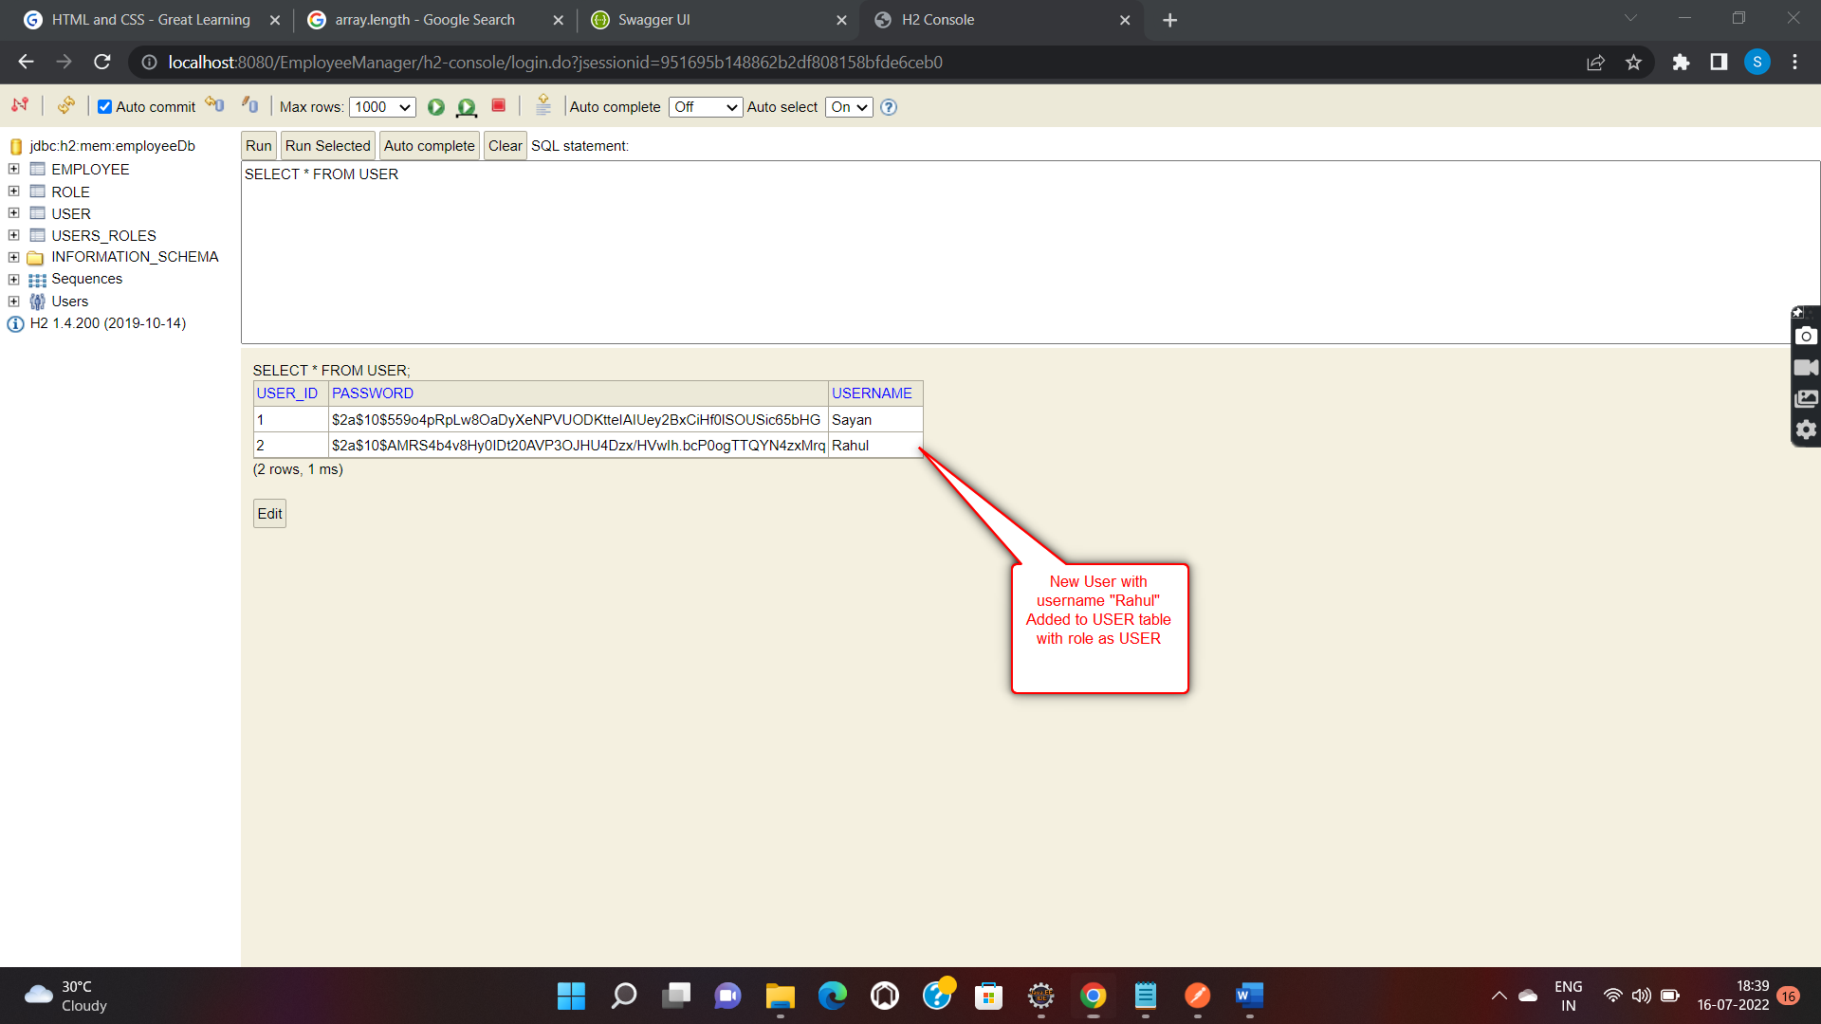

1. Now let’s have a look at all the 4 CRUD operations on our Entity i.e Employee

5.1) **READ OPERATIONS**

5.1.a) Reading all the existing list of Employees from h2 DB :

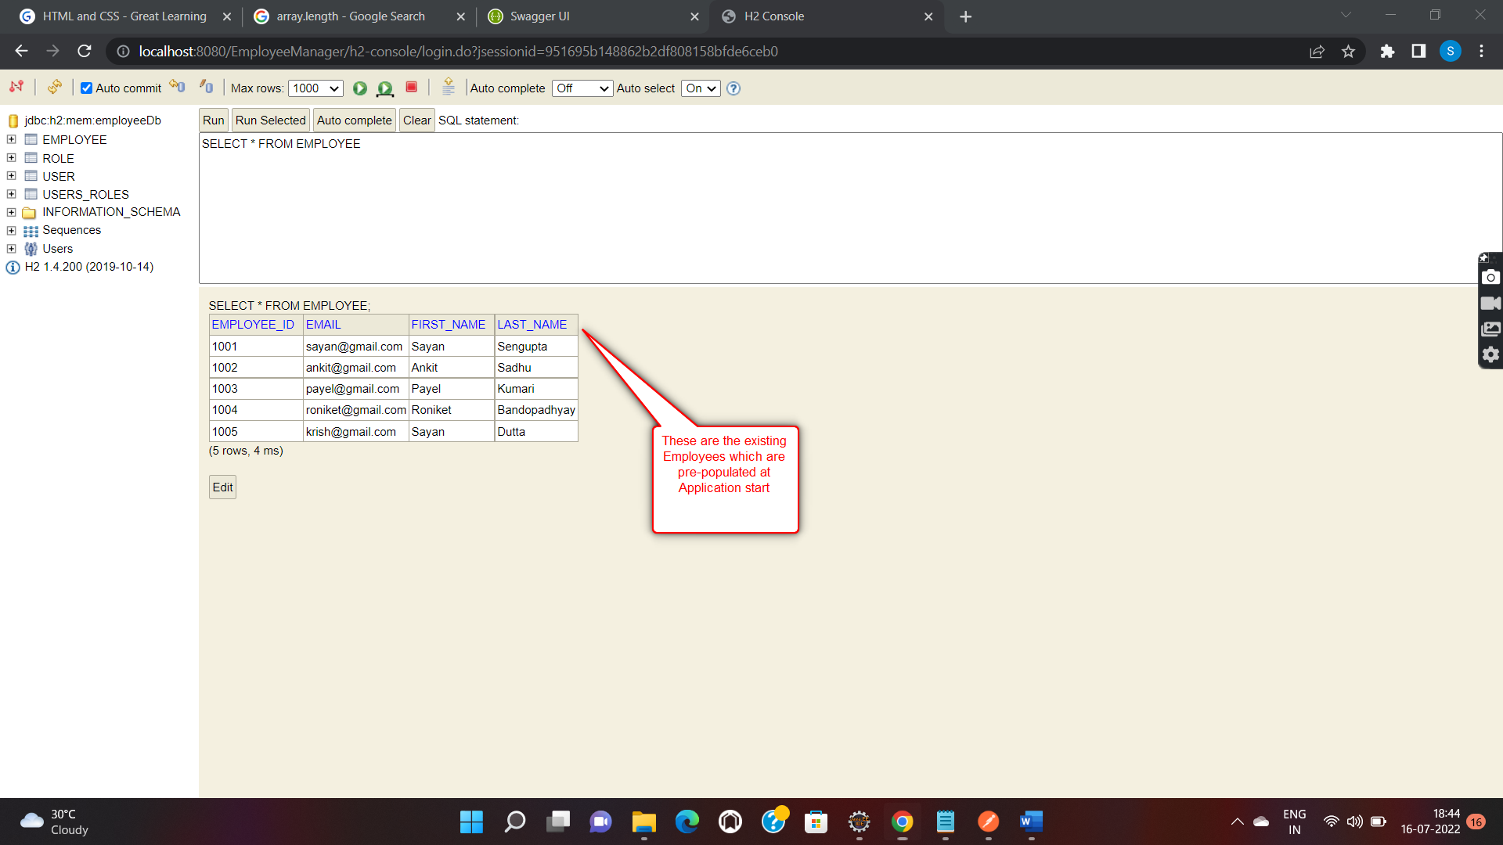

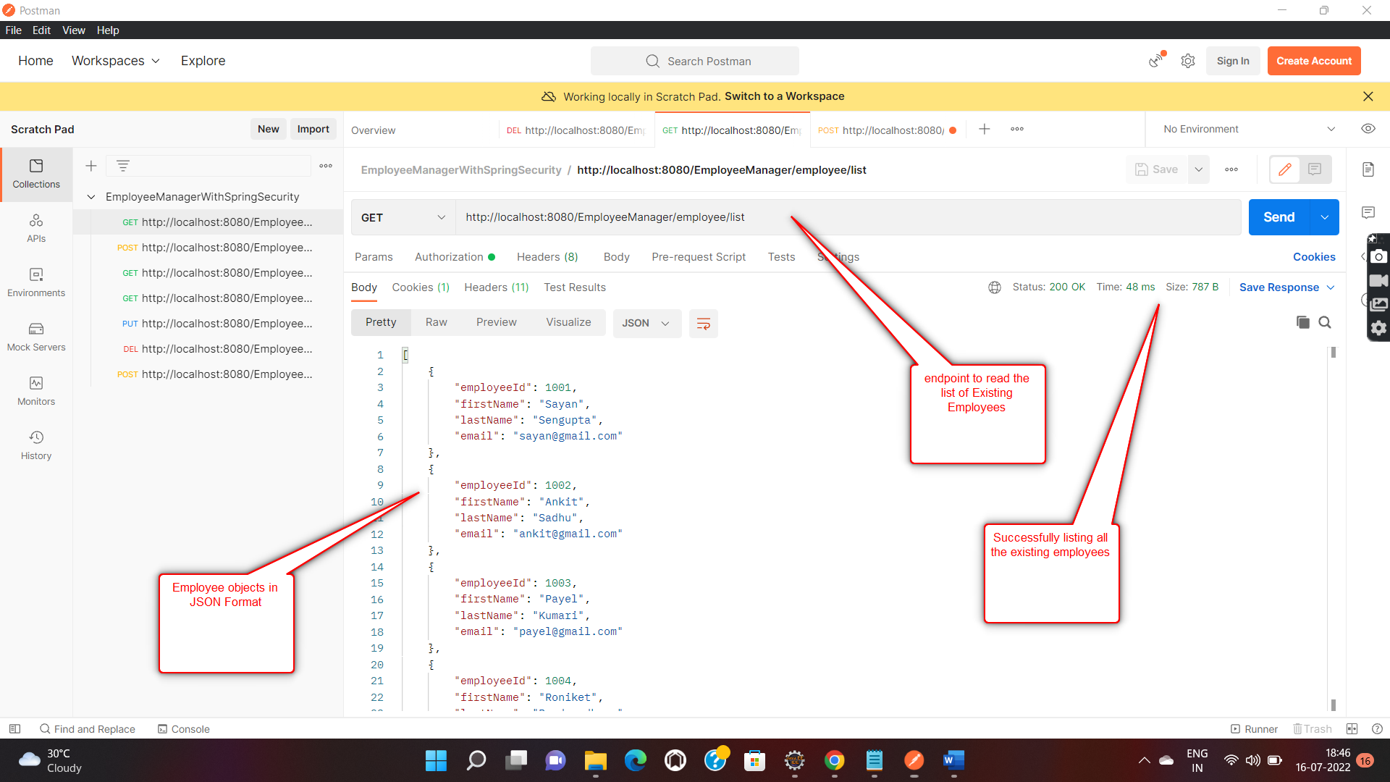

5.1.b) Searching an Employee by their ID :

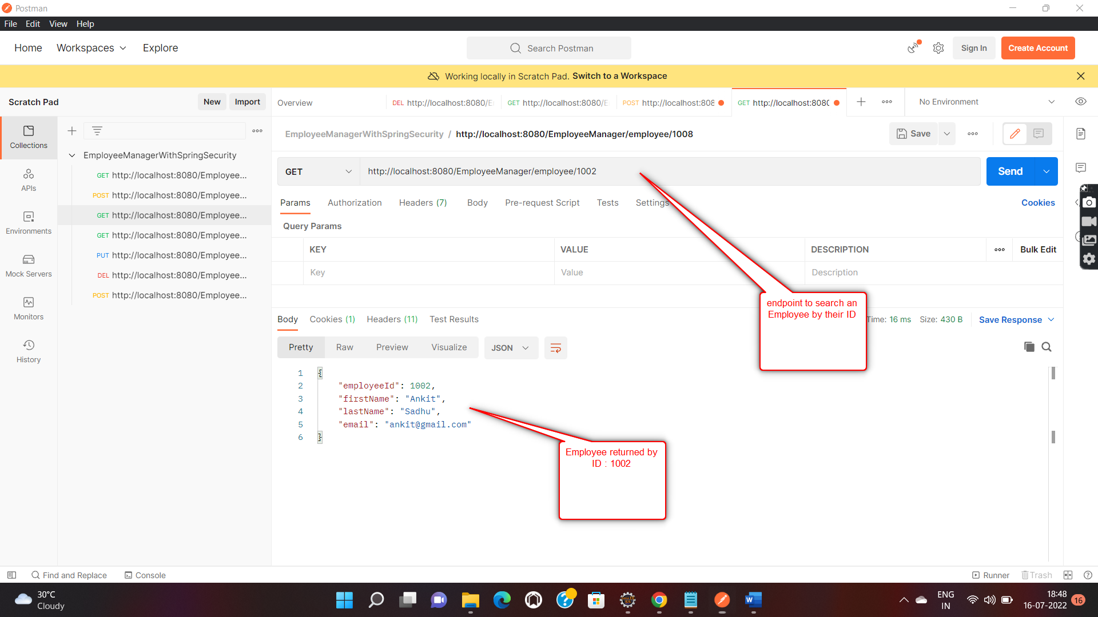

5.2.c) Searching all the Employees with a given First Name :

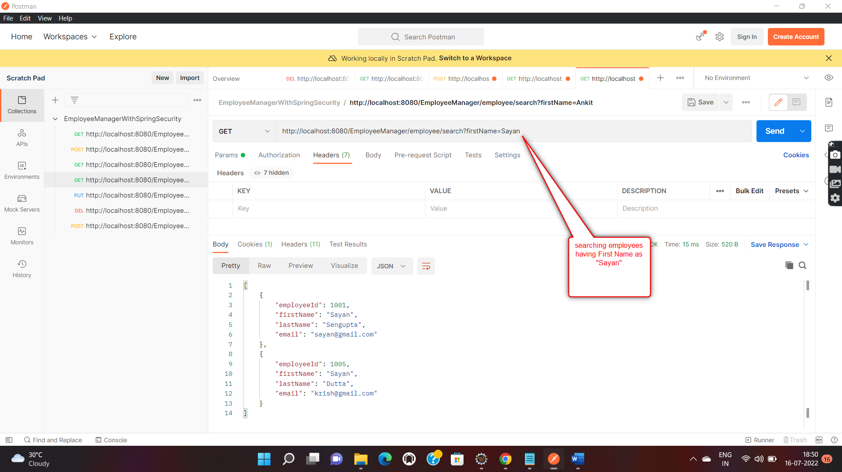

5.2.d) Displaying Employees in Sorted order either Ascending or Descending based on their First Name :

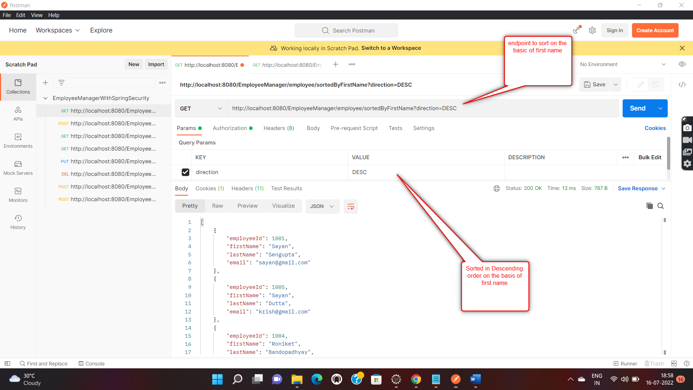

5.2) **CREATE** Operation

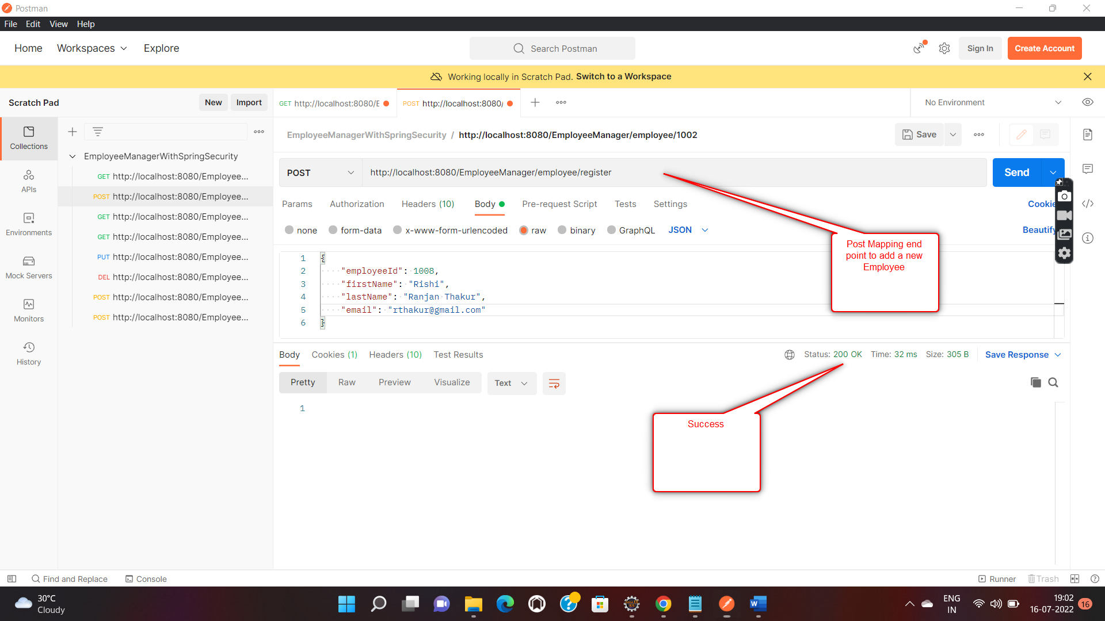

Let’s also verify in DB as well :

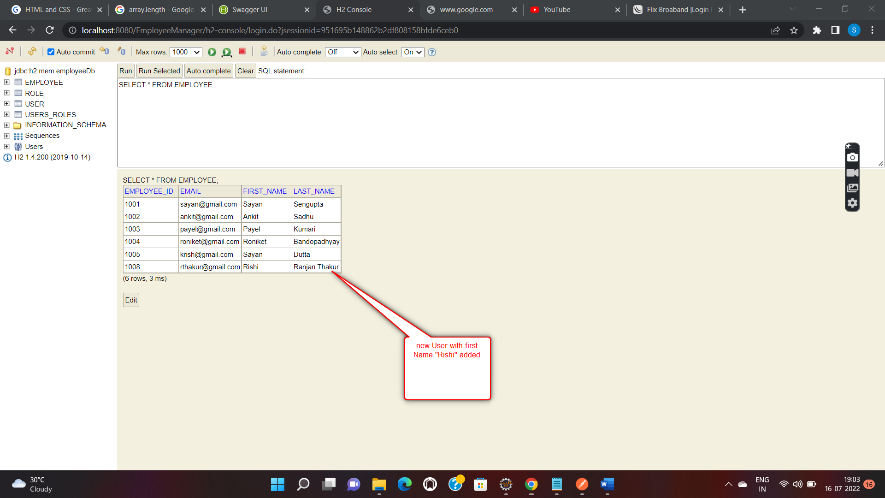

5.3) **UPDATE** Operation

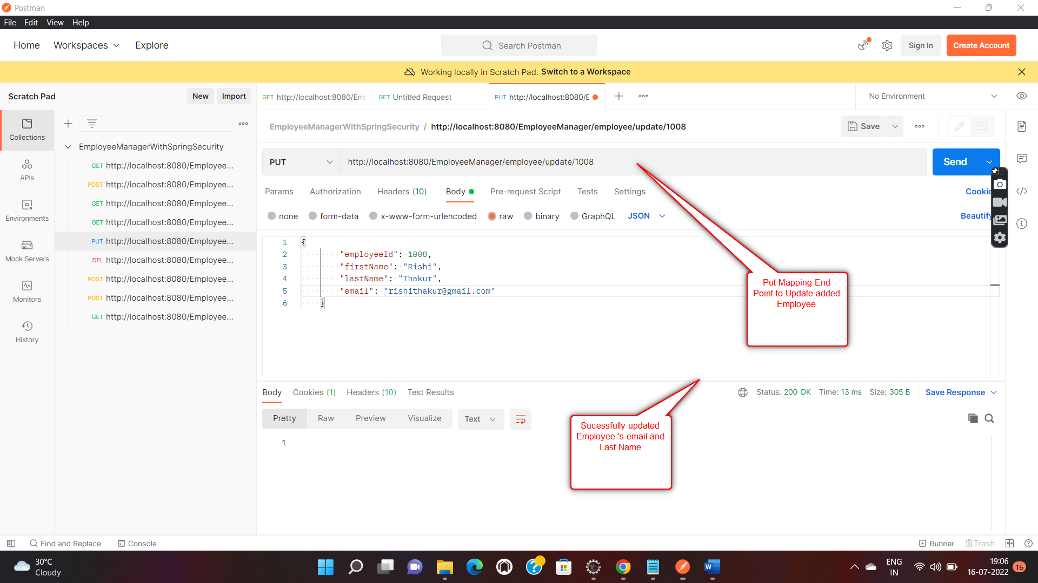

Let’s cross check in h2 DB :

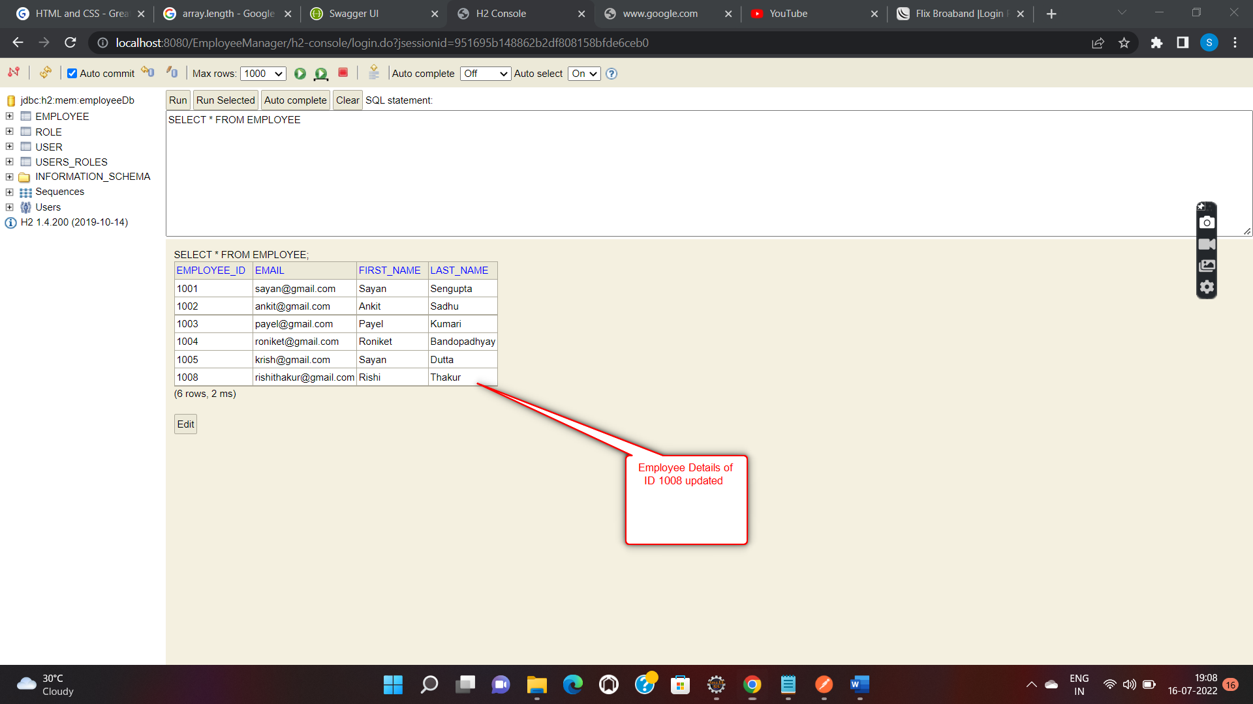

5.4) **DELETE** Operation

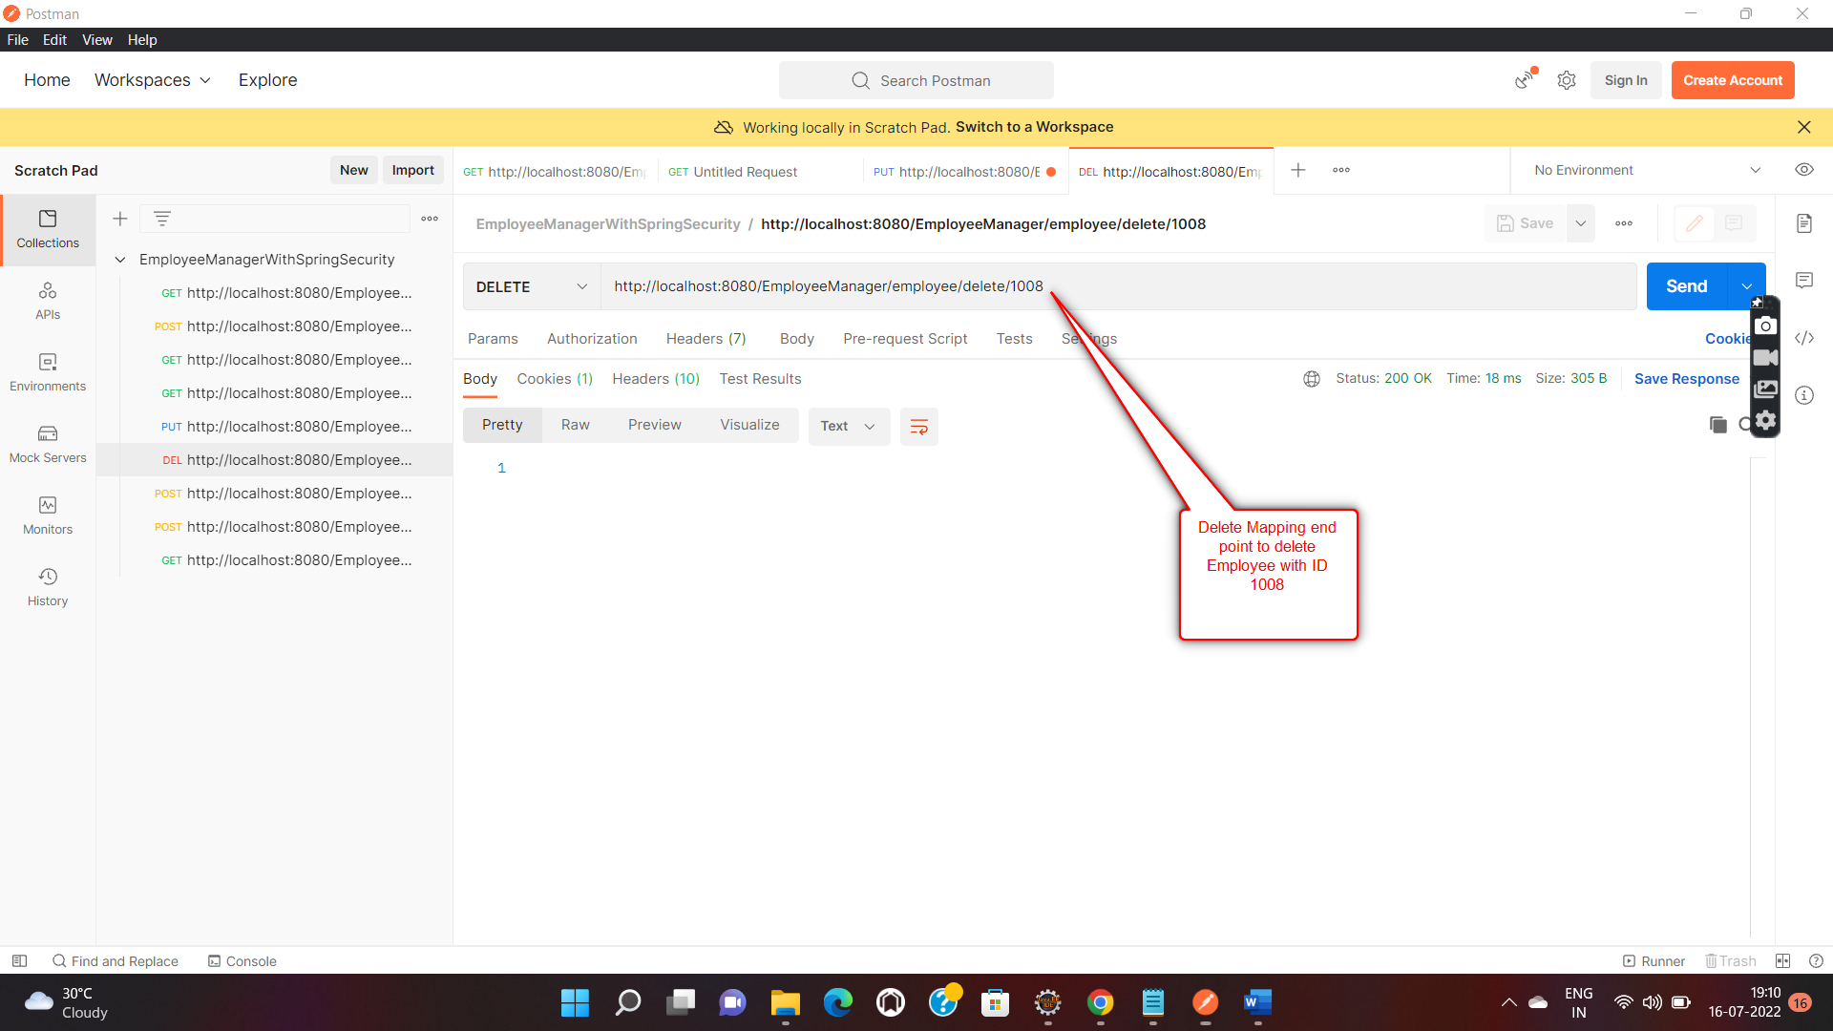

Let’s check if Deletion happened successfully from h2 DB as well

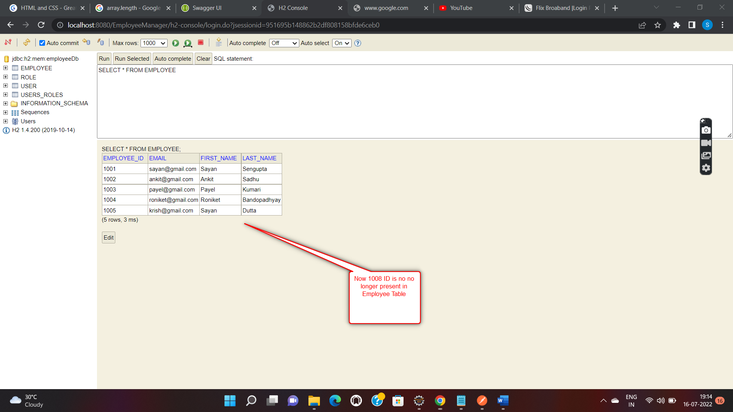

1. Now Let’s take a look at Security Configurations:

6.1) **Authentication:**

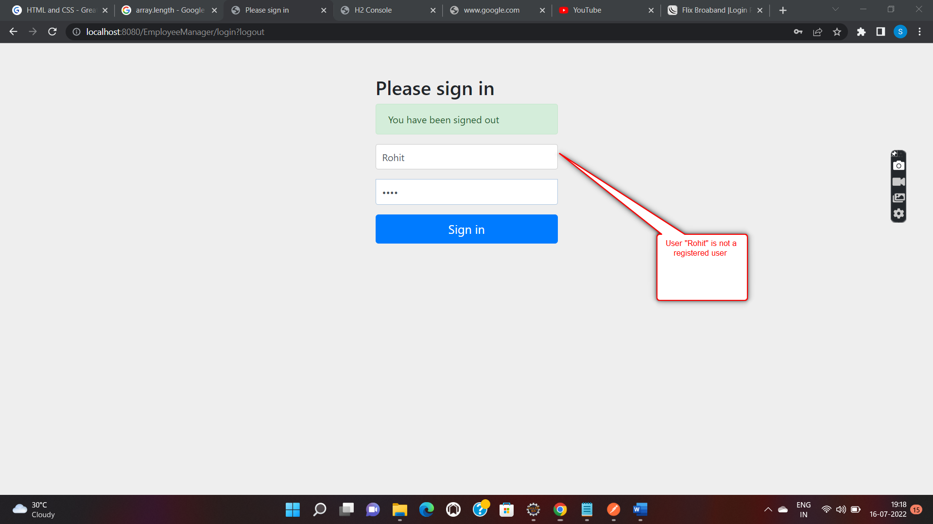

Login Failed :

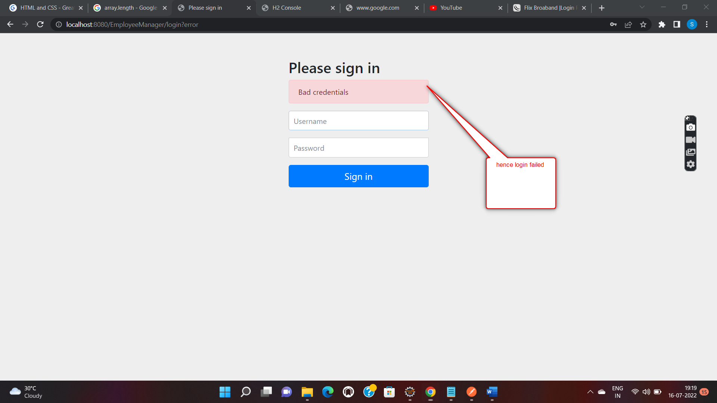

6.2) Login Success

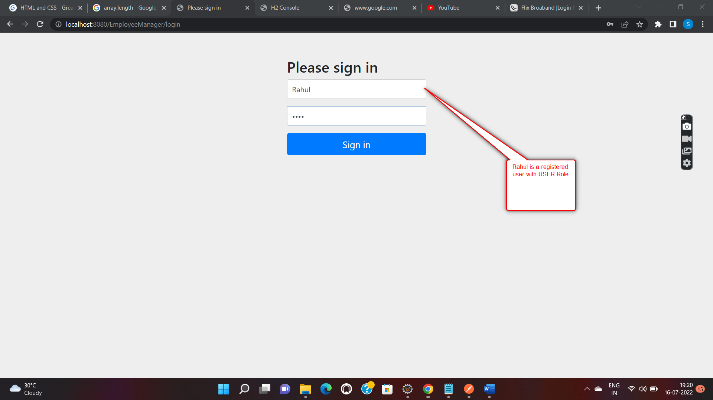

Since now we are Logged in with USER Role. Let’s check our Authorization in action now. USER cannot perform any operations on our application. So in case we try to perform any operation with this user, we are expecting a **403** Unauthorized Error.

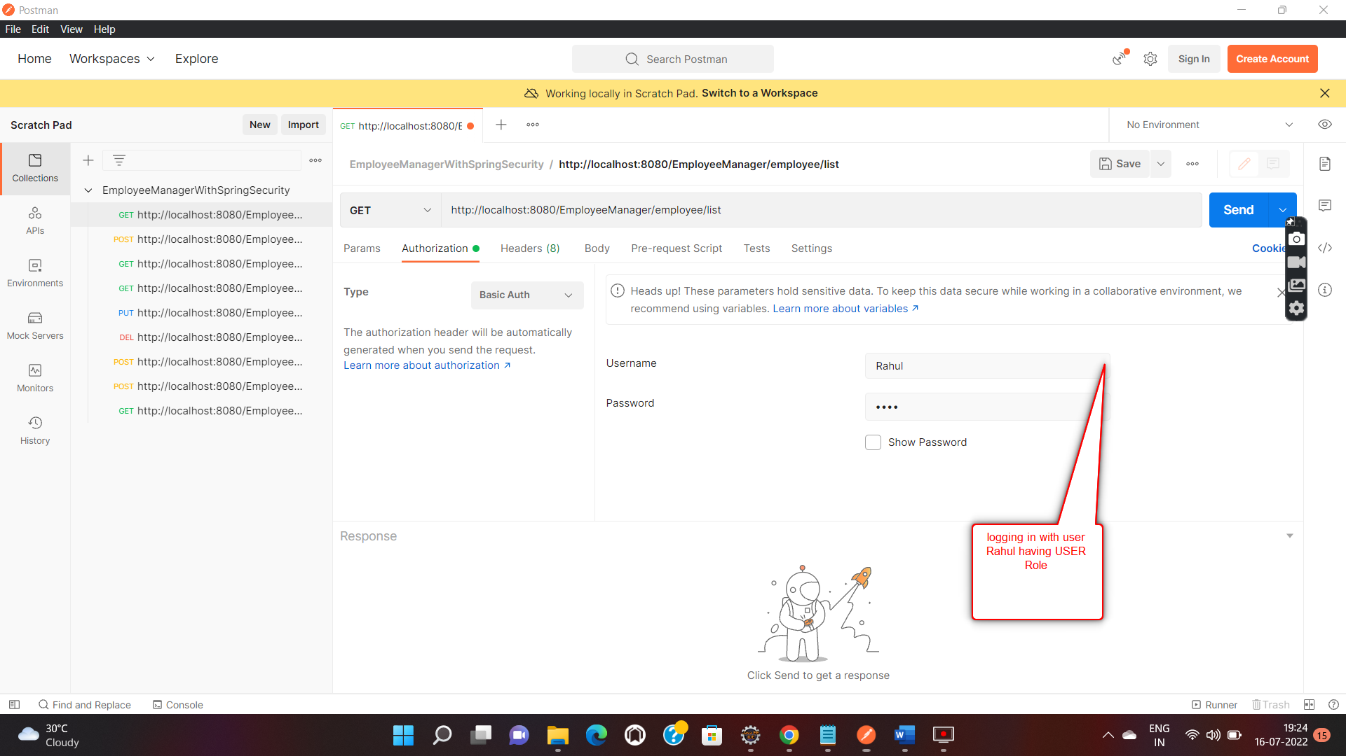

Spring Security Authorization in Action :

